Window Treatments
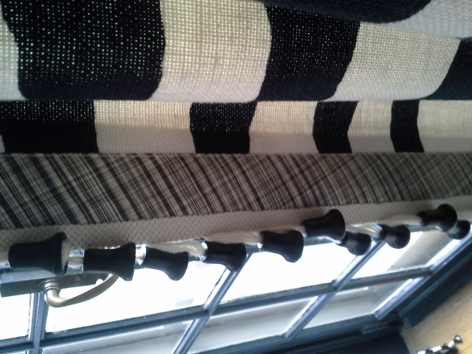
Details! Details! Details! We found many great examples in the Greensboro Designer Showhouse of how custom window treatments can impact a room. One favorite was on the windows of a relaxed bedroom; the drapery uses three coordinating fabrics and a great trim. One would be inclined to use such a trim on a horizontal line, but the designer turns it on the vertical and the bell-shaped baubles drape in a much more interesting way.

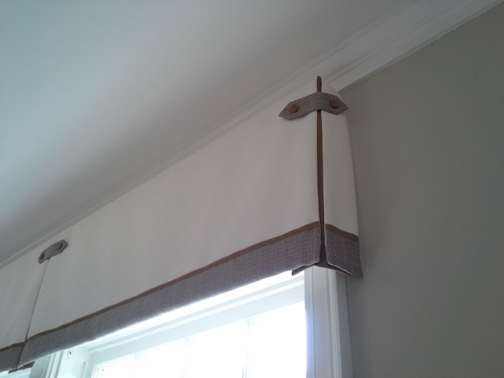
In a tailored bedroom was a board-mounted valance with a contrasting and inverted pleat, bottom fabric-band with top trim, and button placket detail. Very handsome!

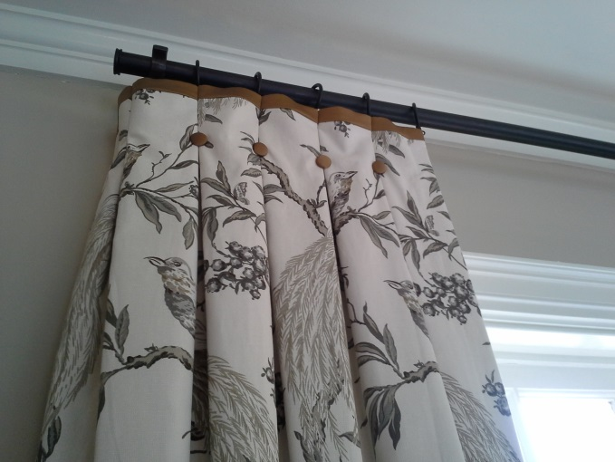
A simple but interesting drapery is this top-trimmed, button-detailed, inverted pleat drapery.
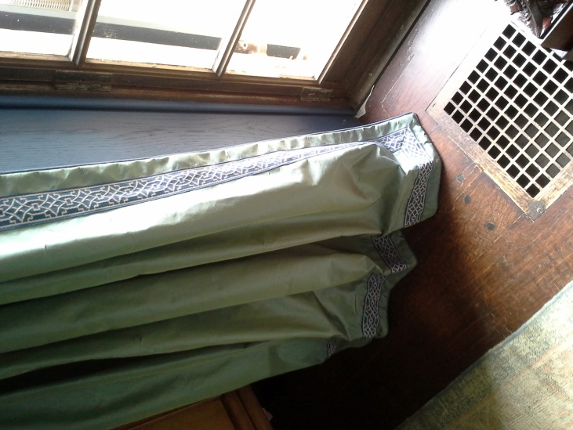
Fabric selection can make all the difference in the world! This sumptuous living room window treatment is styled with contrasting lip cord plus a classic motif flat band trim mitered at the corners. Professional construction and installation is a must when the drapery needs to break “just so.” Just another detail!

Here are some samples of Ramsey Interiors custom window treatments from a few recent projects.

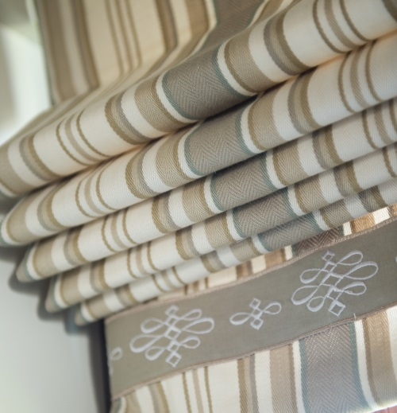
Roman shades are a classic. Trimmed with a flat band in a classic motif makes for an understated, clean window treatment.
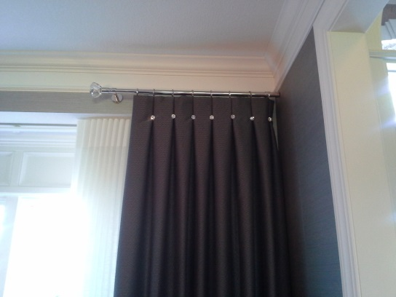
For just a little bling in the dining room, fabric with a subtle texture is used for stationary panels. The inverted pleats are embellished with crystal buttons, and a crystal finial tops off the rod.
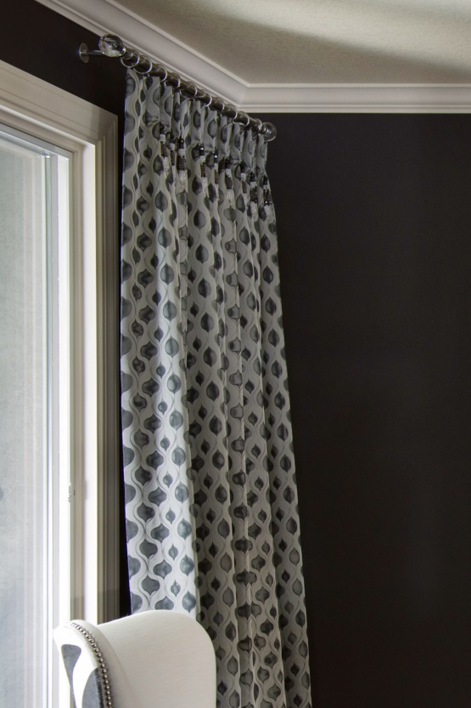
A sheer white, patterned face fabric backed with a sheer black fabric creates a light and airy frame for the window in this dramatic black and white dining room. Handmade crystal bead drops adorn the pleats. Crystal finials were a must!

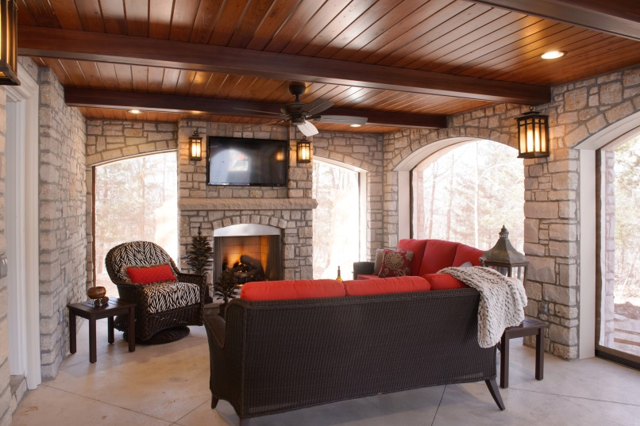
Window treatments don’t necessarily have to mean fabric and trims! This outdoor living space called for motorized screens throughout to block bugs, wind and other natural elements. They recess into the rock walls above the windows when fully opened.

